TITLE ENGLISH LANGUAGE (AN, 18, CENTER, UPPERCASE)
TAJUK BAHASA MELAYU (AN, 18, CENTER, UPPERCASE)

Author (AN, 14, Bold, Centre, Capitalize Each Word) ¹

¹Author details (AN, 12,)

Accepted date:
Published date:

To cite this document:

__________________________________________________________________________________________

Abstract: (AN, 12, single spacing).
Abstrak: (AN, 12, single spacing).

Keywords: (AN, 12, italic, single spacing)
Kata Kunci: (AN, 12, italic, single spacing)

PENGENALAN (AN, 12, UPPERCASE, bold, align left)

Malaysia menyediakan pelbagai program untuk membantu …… (AN, 12, single spacing, align left)

KAJIAN LITERATUR (AN, 12, UPPERCASE, bold, align left)

Konsep Keusahawanan (AN, 12, bold, Capitalize Each Word, align left)

Motivasi Usahawan (AN, 12, bold, Capitalize Each Word, italic, align left)

Menurut Ali (2018)….……. (AN, 12, single spacing, align left)

Jadual 1: Contoh (AN, 10, single spacing, bold, centre)
Contoh | Contoh | Contoh
Contoh | Contoh | Contoh
Contoh | Contoh | Contoh

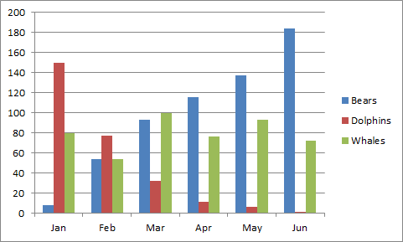
Rajah 1: Contoh (AN, 10, single spacing, bold, centre)

Rujukan (APA Sixth Edition) – 10 rujukan (Minimum)

